**Development of web applications Project**

**Metro Schedule website**

**Hussain Halaj U16107177**

**Mohamed Ashraf U15104115**

**Salah Ahmed U14210368**

**College of Computing and Informatics**

**University of Sharjah**

**December 2019**

# Introduction

Our project is an online metro website that users can go to and sign up, and learn all about the metro. On the home page the user would get news updates on the metro, and they can find information such as the map of the routes that the metros take in Dubai. The schedule page shows the user the schedule and timings of the metros including information such as, the departure time and station and arrival time and destination.

We have developed this project using the following tools:

* HTML: Page layout has been designed in HTML
* CSS: has been used for all the designing parts.
* PHP: All the business and frontend logic has been implemented in PHP.
* MySQL: MySQL Database has been used as a database for the project.
* XAMPP: Project will be run over the Apache server.

# Functional Requirements

This project can perform the following:

1. **Create an account:** our website allows the user to register to our website by filling their information and choosing a password. The password is encrypted via MD5. All the data filled will be inserted in the database.
2. **Log in:** the user will be able to login using the information he registered with. This will be verified by checking the matching between the input and the database.
3. **Validation:** our website validates the users input such as email format and password length. As well as display the errors when the validations are not met.
4. **Session:** we have also implemented the session functionality into our website which allows the user to maintain a single session after they login till they log out. And we show this by displaying a message at the top of our website. With the users name and that is maintained throughout the session.
5. **Display train schedule from our database:** our website has a page that displays a table that is stored in the database. Which shows the train schedule.

## ER Diagram

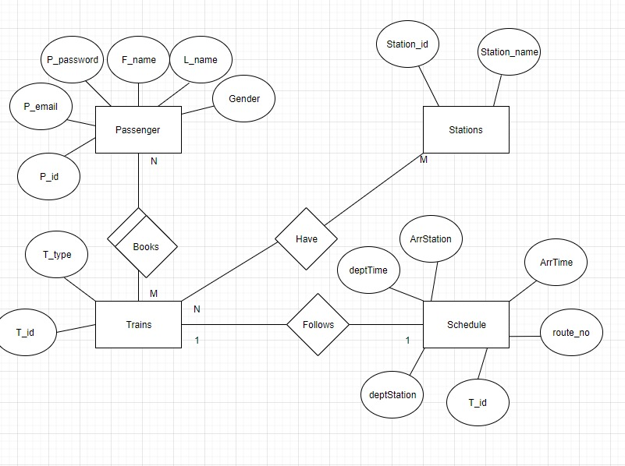

## Tables

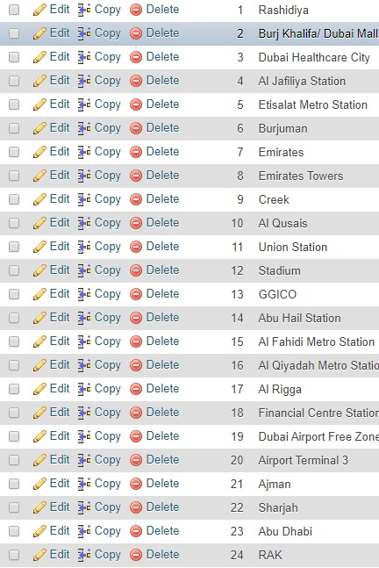Train Types: Stations:

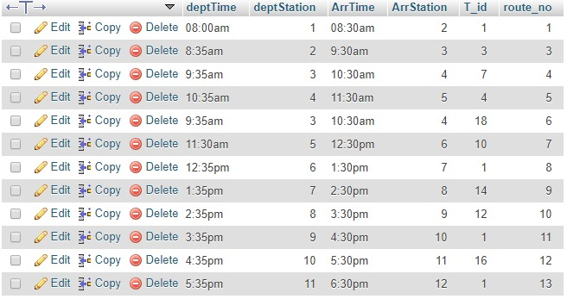Train schedule:

User name and password: